**A**

**PROJECT REPORT**

**ON**

**BIKE SHOWROOM MANAGEMENT SYSTEM**

**FOR MY WINGS HONDA**

**BY**

**HRUSHIKESH JAGTAP**

**OMKAR SATHE**

**BBA(CA)- SEM VI**



**Maharashtra Education Society’s**

**GARWARE COLLEGE OF COMMERCE**

**( BBA(CA) DEPARTMENT)**

**KARVE ROAD , PUNE-411004**

**SAVITRIBAI PHULE PUNE UNIVERSITY**

**2018-2019**



**MAHRASHTRA EDUCATION SOCIETY’S**

**GARWARE COLLEGE OF COMMERCE**

KARVE ROAD, DECCAN GYMKHANA,

PUNE-411004

**Certificate**

This is to certify that Omkar Sathe and Hrushikesh Jagtap has successfully completed the project entitled “SCHOOL ADMISSION MANAGEMENT SYSTEM” and has submitted the same to the satisfaction during the academic year 2018 – 2019 towards partial fullfillment of the degree ‘Bachelor of business administration computer application’,of the university of Pune.

(Project Guide) (BCA InCharge) (Principal)

(Internal Examiner) (External Examiner)

**ACKNOWLEDGEMENT**

It Gives us immense pleasure to express our sincere to ‘M.E.S Boys School’ .

I would like to express our sincere and deep gratitude to our internal project guide Mrs. SampadaNaiksatam, for her valuable guidance and suggestions.

I would also like to thank the coordinator for giving us guidance and timely help.

**Mr.OmkarSathe**

**Mr.HrushikeshJagtap**

**(BCA Sem VI)**

**TABLE OF CONTENTS**

**ChapterNo.Title**

1. **Synopsis**
2. **CompanyProfile**
3. **ProjectProfile**
4. **Study of existing system**
   1. Study of existing system
   2. Client requirement specification
   3. Problems with existing system
   4. Fact finding methods
5. **Proposed System**
   1. Scope of proposed system
   2. Objectives of proposed system
   3. Feasibility study
   4. Hardware and Software Requirement
6. **System Analysis**
   1. Context Level Diagram
   2. Data Flow Diagram
   3. Entity Relationship Diagram
7. **System Design**
   1. Table Design
   2. Form Design(With Input Values)
   3. Report Design(With Data)
8. **System Limitations**
9. **Future Enhancements**
10. **Bibliography**

**SYNOPSIS**

|  |  |
| --- | --- |
| **Project Title:** | School Management Management system |
| **Name of the Company:** | M.E.S. Boys Highschool |
| **Technology:** | Java  MS Access |
| **Team Members:** | OmkarSathe  HrushikeshJagtap |
| **Objectives:** | The main objective of the project is to manage the details of the school , students , class & teachers. The project is totally built at administrator end and thus only administrator is guaranteed the access. The purpose of the project is to build an application program to reduce work for managing the schools, class wise admission details. |
| **Modules:** | 1. Login Module 2. School Information Module 3. School Management Module 4. Fees Payment module 5. Search Module 6. Admission Module |

**Company Profile**

* **Name of the company** : My Wings Honda Showroom.
* **Head Office** : Pune, Maharashtra.
* **Key People** :Vasudev Balwant Phadke.
* **Website** : bhavehighschool.org

BhaveHighschool was established in 1860(Also known as M.E.S. Boys Highschool) is a school and junior college based in Pune , Maharashtra , India .The Institution is run by the Maharashtra Education Society. A Private Education Institution founded by Vasudev Balawant Phadke ,Vaman Prabhakar Bhave and Laxman Narhar Indapurkar in 1860.

**Project Profile**

School Admission Management is becoming very essential component in education in this modern day age . With the help of school admission system we can gather all the useful information needed to the management in few clicks . Schools Admission System consists of different modules such as Logic , forms and reports , our main purpose is to create software which will manage the working of these different modules.

School Admission System is the Intranet based which will help the student to the admission , view attendance , view Results , etc. With the help of this system admin can easily maintain the records of many students without any paperwork. Admin can find information of any student easily. The software manages the information about various users including faculties , information about subjects offered in various semisters, marks obtained by students in different semisters , daily attendance for employees and students and staff.

**Study of Existing System**

* Currently, the system is totally manual.
* The manual system is slow than the computerized system.
* The current system is very time consuming.
* It is very complex system.
* It is required more clerical work and use more than power.
* The current system is not user friendly.
* It takes too much cost to perform procedure.
* In this system , paper losing or paper burning is possible.
* It is difficult to store the data.
* In the Student Admission Process ,lots of paperwork, filling and storage required.
* Manually the procedure takes a good amount manpower ,it is uneconomical and inaccurate.
* Management of admission procedure, it needs criteria to the admission.
* In admission process, it needs the merit lists of students.
* Admission forms are given to the student for filling admission form.
* Rules and regulations are applied.
* For admission process student are counted , hoe many students have admitted.
* Then ID cards are distributed to the students.

**Client Requirement Specification**

According to users requirements our system provides a simple and attractive Graphical user interface & different modules so that the working process remains simple and also satisfies the needs of user.

Following are the requirements of users gathered while the process of system analysis and requirement gathering :

1. Simple and effective graphical user interface which will make the process simpler and consume less time.
2. Managing and maintaining huge database.
3. Preventing loss of data.
4. Security to system is the important point.
5. Activities like student registration , faculty registration , faculty attendance , fees, cours details, reports must be restricted to admin only.
6. Activities like student’s attendance , mark sheets, updating personal information.
7. Activities like updating own information , viewing mark sheets and viewing own attendance.(No updating or deletion allowed).

**Problems with Existing System**

The current system that is handled is truly manual . It hardly has anything to do with maintaining data on the computer . The problem of the existing system are:

* Tremendous paperwork
* No manpower to handle data
* Data is maintained in files
* Difficulty is searching of the records
* Tremendous time required

**Table Design**

1. **Login Master**

|  |  |  |  |  |
| --- | --- | --- | --- | --- |
| Column Name | Datatype | Size | Constraint | Description |
| usernm | Text | 20 | Primary key | User Name |
| password | Number | 8 | Not Null | Login password |
| que | Text | 50 | Not Null | Security Question |

**2)fifth**

**Des. : Fifth Standard , Admission Master**

|  |  |  |  |  |
| --- | --- | --- | --- | --- |
| Column Name | Datatype | Size | Constraint | Description |
| Stud_id | Number | 10 | Primary key | Student ID |
| Stud_fname | Text | 30 | Not Null | Student First name |
| Stud_mname | Text | 30 | Not Null | Student Middle name |
| Stud_surname | Text | 30 | Not Null | StudentSurname |
| dob | Number | 10 | Not Null | Date of Birth |
| contact | Text | 10 | Not Null | Contact number |
| address1 | Text | 50 | Not Null | Address 1 |
| address2 | Text | 50 | Not Null | Address 2 |
| houseno | Number | 10 | Not Null | House number |
| pincode | number | 10 | Not Null | Pincode |
| medium | Text | 20 | Not Null | Medium for admission |
| pic | Text | - | Not Null | Picture of students |

**3)sixth**

**Des. :Sixth Standard , Admission Master**

|  |  |  |  |  |
| --- | --- | --- | --- | --- |
| Column Name | Datatype | Size | Constraint | Description |
| Stud_id | Number | 10 | Primary key | Student ID |
| Stud_fname | Text | 30 | Not Null | Student First name |
| Stud_mname | Text | 30 | Not Null | Student Middle name |
| Stud_surname | Text | 30 | Not Null | Student Surname |
| Dob | Number | 10 | Not Null | Date of Birth |
| Contact | Text | 10 | Not Null | Contact number |
| address1 | Text | 50 | Not Null | Address 1 |
| address2 | Text | 50 | Not Null | Address 2 |
| houseno | Number | 10 | Not Null | House number |
| Pincode | number | 10 | Not Null | Pincode |
| Medium | Text | 20 | Not Null | Medium for admission |
| Pic | Text | - | Not Null | Picture of students |

**4)seventh**

**Des. :Seventh Standard , Admission Master**

|  |  |  |  |  |
| --- | --- | --- | --- | --- |
| Column Name | Datatype | Size | Constraint | Description |
| Stud_id | Number | 10 | Primary key | Student ID |
| Stud_fname | Text | 30 | Not Null | Student First name |
| Stud_mname | Text | 30 | Not Null | Student Middle name |
| Stud_surname | Text | 30 | Not Null | Student Surname |
| Dob | Number | 10 | Not Null | Date of Birth |
| Contact | Text | 10 | Not Null | Contact number |
| address1 | Text | 50 | Not Null | Address 1 |
| address2 | Text | 50 | Not Null | Address 2 |
| houseno | Number | 10 | Not Null | House number |
| Pincode | number | 10 | Not Null | Pincode |
| Medium | Text | 20 | Not Null | Medium for admission |
| Pic | Text | - | Not Null | Picture of students |

**5)eighth**

**Des. :Eighth Standard , Admission Master**

|  |  |  |  |  |
| --- | --- | --- | --- | --- |
| Column Name | Datatype | Size | Constraint | Description |
| Stud_id | Number | 10 | Primary key | Student ID |
| Stud_fname | Text | 30 | Not Null | Student First name |
| Stud_mname | Text | 30 | Not Null | Student Middle name |
| Stud_surname | Text | 30 | Not Null | Student Surname |
| Dob | Number | 10 | Not Null | Date of Birth |
| Contact | Text | 10 | Not Null | Contact number |
| address1 | Text | 50 | Not Null | Address 1 |
| address2 | Text | 50 | Not Null | Address 2 |
| houseno | Number | 10 | Not Null | House number |
| Pincode | number | 10 | Not Null | Pincode |
| Medium | Text | 20 | Not Null | Medium for admission |
| Pic | Text | - | Not Null | Picture of students |

**6)ninth**

**Des. :Ninth Standard , Admission Master**

|  |  |  |  |  |
| --- | --- | --- | --- | --- |
| Column Name | Datatype | Size | Constraint | Description |
| Stud_id | Number | 10 | Primary key | Student ID |
| Stud_fname | Text | 30 | Not Null | Student First name |
| Stud_mname | Text | 30 | Not Null | Student Middle name |
| Stud_surname | Text | 30 | Not Null | Student Surname |
| dob | Number | 10 | Not Null | Date of Birth |
| contact | Text | 10 | Not Null | Contact number |
| address1 | Text | 50 | Not Null | Address 1 |
| address2 | Text | 50 | Not Null | Address 2 |
| houseno | Number | 10 | Not Null | House number |
| pincode | number | 10 | Not Null | Pincode |
| medium | Text | 20 | Not Null | Medium for admission |
| Pic | Text | - | Not Null | Picture of students |

**7)tenth**

**Des. :Tenth Standard , Admission Master**

|  |  |  |  |  |
| --- | --- | --- | --- | --- |
| Column Name | Datatype | Size | Constraint | Description |
| Stud_id | Number | 10 | Primary key | Student ID |
| Stud_fname | Text | 30 | Not Null | Student First name |
| Stud_mname | Text | 30 | Not Null | Student Middle name |
| Stud_surname | Text | 30 | Not Null | Student Surname |
| Dob | Number | 10 | Not Null | Date of Birth |
| Contact | Text | 10 | Not Null | Contact number |
| address1 | Text | 50 | Not Null | Address 1 |
| address2 | Text | 50 | Not Null | Address 2 |
| Houseno | Number | 10 | Not Null | House number |
| Pincode | number | 10 | Not Null | Pincode |
| Medium | Text | 20 | Not Null | Medium for admission |
| Pic | Text | - | Not Null | Picture of students |

**NOMENCLATURE**

**Symbols are used in ERD**

Following are the symbol used for drawing the Entity Relationship Diagram

* Entity
* Relationship
* One **1**
* Many **M**

**Context Level Diagram (CLD)**

Gives Information of school

Get Information of school

Admin

Student

Request for Admission

Gives Admission to the students

Cashier

Get Admission to the School

Fees Payment

Gives Receipt to students

Get Reciept

**Data Flow Diagram (DFD)**

Student Details

Login

Details

Admin Mst

Student Mst

Submit other details

Fill Admission Form

Admission Mst

Admin Mst

Collect the forms and details

Manages the details

Fees Payment

Admission Mst

Student

& other details

Provide Services

Collect Receipt

Provide Details

Collection of fees

Fees

Collect other details & Services

Fees Details

Admin

Registration details

Registration

Reports

Students details

Admission Mst

Admin Mst

Feedback details

Feedback Mst

**Entity Relationship Diagram (ERD)**

M

M

M

M

M

Mm

M

M

1

1

Give

Get

View

Student

Feedback

View

Admission

Admin

Registration

Get

View

**BIBLIOGRAPHY**

* Java
* MS Access
* Software Engineering

***Login Form***

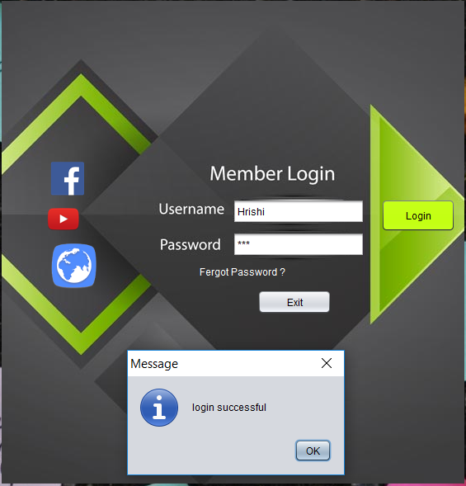

***MDI Form***



***Admission Form***

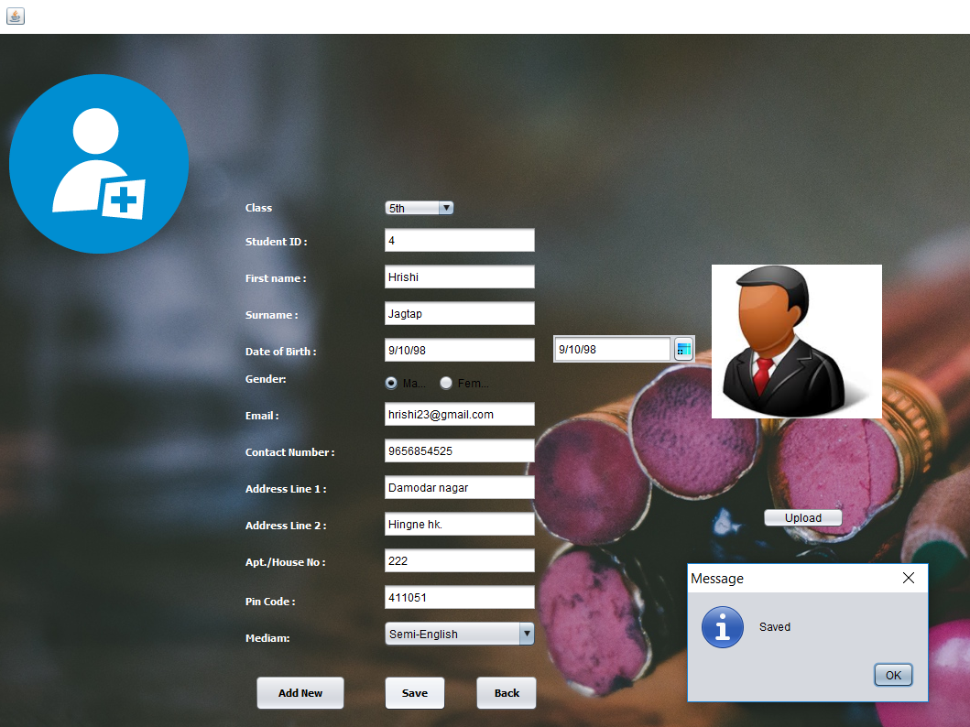

***Search Form***

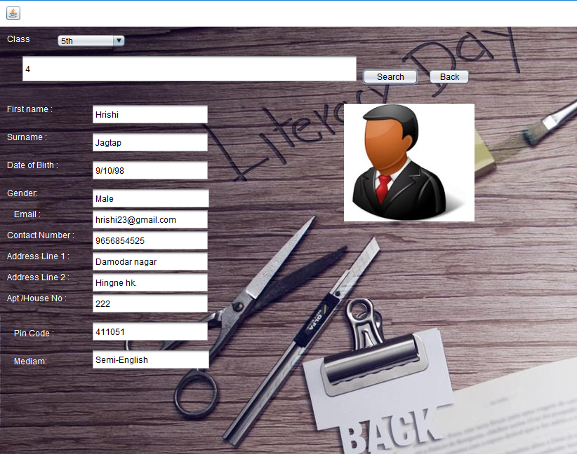

***Update Form***

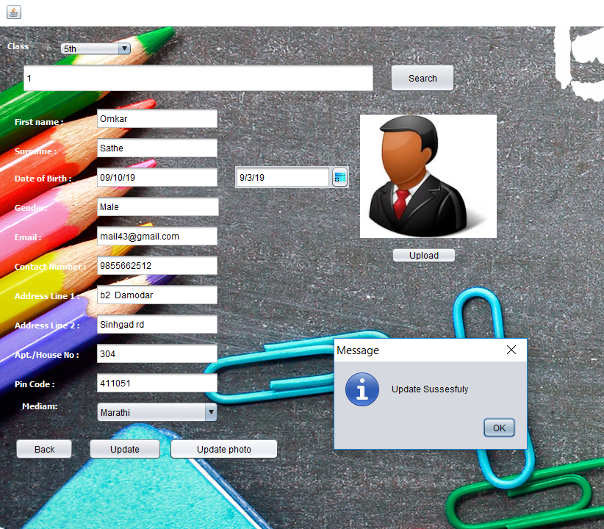

***Forgot Password***

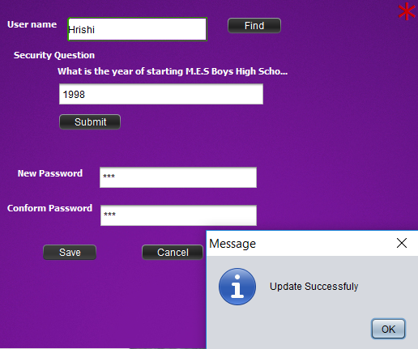

**Reports**

**Fifth Standard Report**

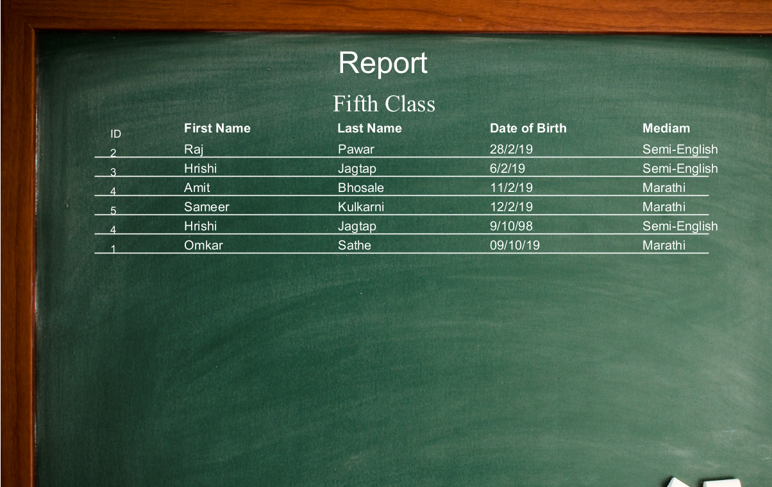

**Sixth Standard Report**

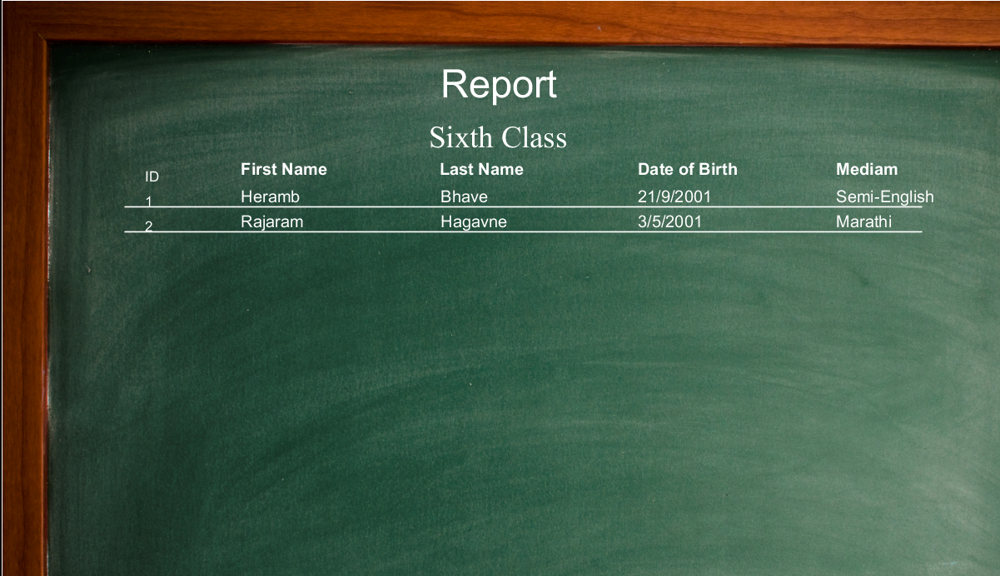

**Seventh Standard Report**

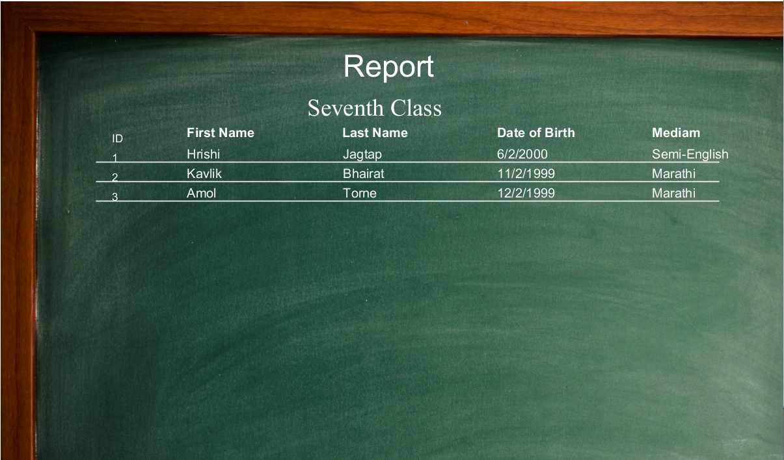

**Eighth Standard Report**

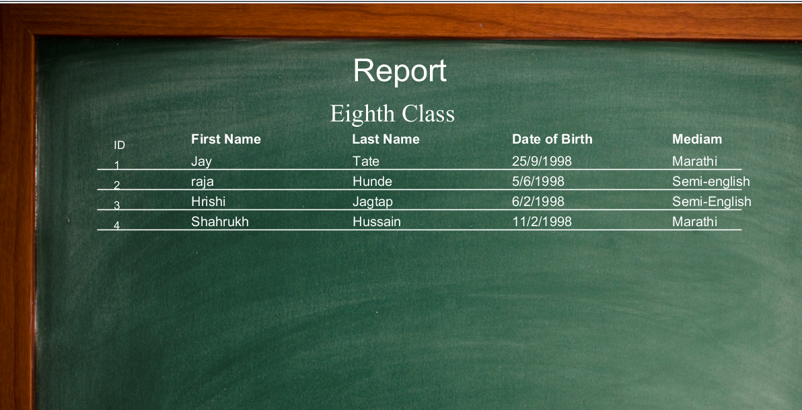

**Ninth Standard Report**

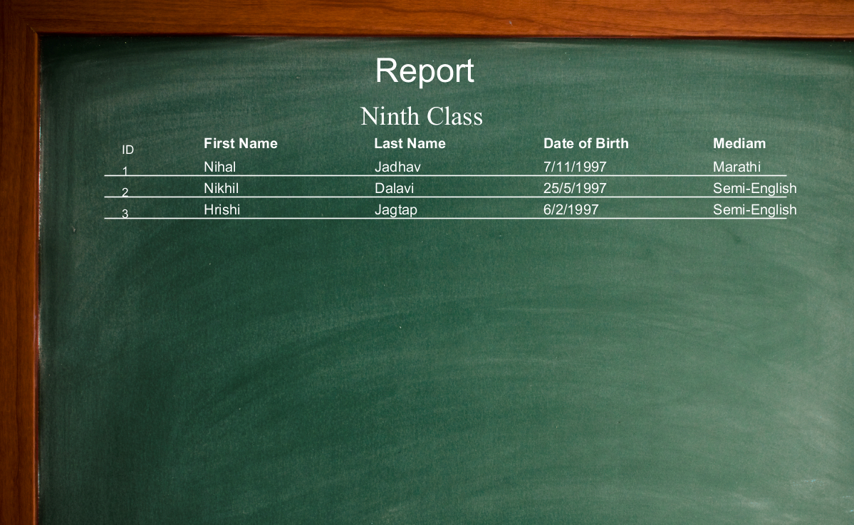

**Tenth Standard Report**

